**Project write up - Brandon Batson**

**Website Project - Digital Technologies**

**I aimed to achieve the following points.**

**At least 3 different pages to navigate between:** Allow users to navigate the page with ease.

**At least one image and text on each page:** The web page is not all just text.

**A consistent header and footer on multiple pages:** Show consistency between pages.

**Use of an external CSS file to style elements:** Makes the web page appealing to look at.

**Timed slideshow of screenshots or photos:** Add some flair to existing images.

**Sound test using the web audio API to demonstrate a number of different sound effects:** Showcase ability to use the web audio API.

**Manipulation of simple shapes using the canvas element:** Showcase ability to use the Canvas.

**Small HTML5 mini game using the canvas element:** Showcase ability to use JavaScript.

**Layout and Style**

I wanted the layout of the website to be easy on the eyes for all users, therefore I went for simplicity when using the empty space on each page, and a colour scheme that is easy on the eyes which is consistent throughout the website that only consists of two colours that are analogous.

This was not a snap decision and beforehand I went through many other colour options, such as a blue fade from top to bottom of the website. I later decided that this was difficult to keep consistent and didn’t look very good either.

For the index page, I decided to use something I learned about while creating this project, which was jQuery. By using “W3Schools” I managed to creating text on the index page that faded in and out as different text each time, eventually looping around and starting again.

Near the end of development, I realised I didn’t have many images on my website. Therefore, to show my understanding of using the <img> tag, I placed an image of an early design of a card from the card game that our team is creating for another project.

**Issues and Fixes**

A small issue that arose near the end of development was that not all systems had HP Simplified, which was what I used as my base text; therefore, I added a secondary text to change to if the system didn’t have HP Simplified, this was Comic Sans MS.

**Menu Bar:** The menu bar caused a lot of problems to do with placement of other divisions or canvases on certain pages. This was due to the fact that the division is alternating from solid to invisible, causing some other divisions to move around the page whenever the menu was activated.

To fix this problem, in the stylesheet I made sure to set absolute positions whenever I made a new division or canvas.

I decided that a menu bar that pops out instead of slowly moves out would be more consistent when it came to creating other pages. Design is always something I’ve struggled with and I’d say that coming up with a unique idea for something such as a website and making it look appealing is a big weakness of mine.

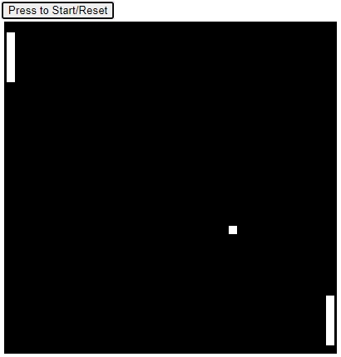**Canvas page:** I wanted to make something on the canvas page that would stand out, so I decided to re-create the classic Atari game “PONG” inside a canvas as a small HTML5 game. It seemed like something I could do that was in my skill range as I enjoy coding a lot more than designing this played more into my strengths**.** I used the script tags to code the game using JavaScript with multiple functions and variables. I used the game as an opportunity to show that I can use sounds on a web page by including the sounds the ball makes when it hits a paddle or the wall.

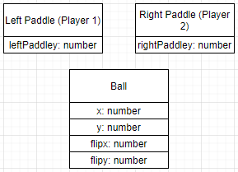An issue I encountered about mid-way through development of the game was that the game would not reset, and the user would have to refresh the page. After many attempts I couldn’t figure out why the variables weren’t resetting, eventually I figured it out and changed the start button into a start/reset button. The issue was that I was trying to create a function that reset all the variables, however the ones that were created in this new function were only local to that function and were not resetting the global ones.

**Analysis**

When it comes to the points I wished to achieve, I believe I managed all but a few. These being that I didn’t include **images on each page.** I felt as I was designing the web page that it didn’t seem like it needed an image on each individual page, however, I still used images in general on some pages. I do believe I have achieved all other points stated at the beginning of this document.

**Conclusion**

Overall, I’d say that my ability to create practical stuff such as the JavaScript mini game is much stronger than my ability to create a unique and good looking website. This is something that will even out the more I attempt to create in the future and hopefully I will get better at coming up with original and unique ideas.

When it came to solving issues related to HTML code I usually spotted what was causing the issue quite quickly, however a lot of the time I also reffered to w3schools and other people’s designs from stack overflow to get an idea of what I should be doing, However when it came to getting the movement for my paddles in the pong mini game I used the code provided on brightspace during the “Audio Test” lecture.